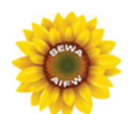 *Annual FREE Health and Resource Fair*

[Sewa-Aifw Free Health & Resource Fair April 22nd](Poster%20SEWA-%20Annual%20FREE%20Health%20and%20Resource%20Fair%202018.docx)

*Sunday April 22, 2018*

*10 AM – 5 PM*

Minnetonka Community Center

14600 Minnetonka Blvd, Minnetonka, MN 55345

* **Dietary seminars**
* **Glucose & Cholesterol Testing**
* **Mammogram Screening**
* **Specialty Medical Consults-Eco cardiogram-Endocrinologist**
* **Immigration one-on-one**
* **Learn about Modern Relationship in Bollywood Era**
* **Meditation**

***In Collaboration with:*** 